**Python Assignment 15**

1.How many seconds are in an hour? Use the interactive interpreter as a calculator and multiply the

number of seconds in a minute (60) by the number of minutes in an hour (also 60).

sol. 60

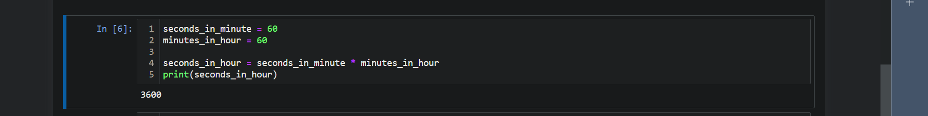

2. Assign the result from the previous task (seconds in an hour) to a variable called

seconds_per_hour.



3. How many seconds do you think there are in a day? Make use of the variables seconds per hour

and minutes per hour.





4. Calculate seconds per day again, but this time save the result in a variable called seconds_per_day



5. Divide seconds_per_day by seconds_per_hour. Use floating-point (/) division.



6. Divide seconds_per_day by seconds_per_hour, using integer (//) division. Did this number agree

with the floating-point value from the previous question, aside from the final .0?



As for second question, yes, the integer division result agrees with the floating-point division result from the previous question. The only difference is that the floating-point result had a .0 decimal part, indicating it was a floating-point number, whereas the integer division result is a whole number without a decimal part.

7. Write a generator, genPrimes, that returns the sequence of prime numbers on successive calls to

its next() method: 2, 3, 5, 7, 11, ...

